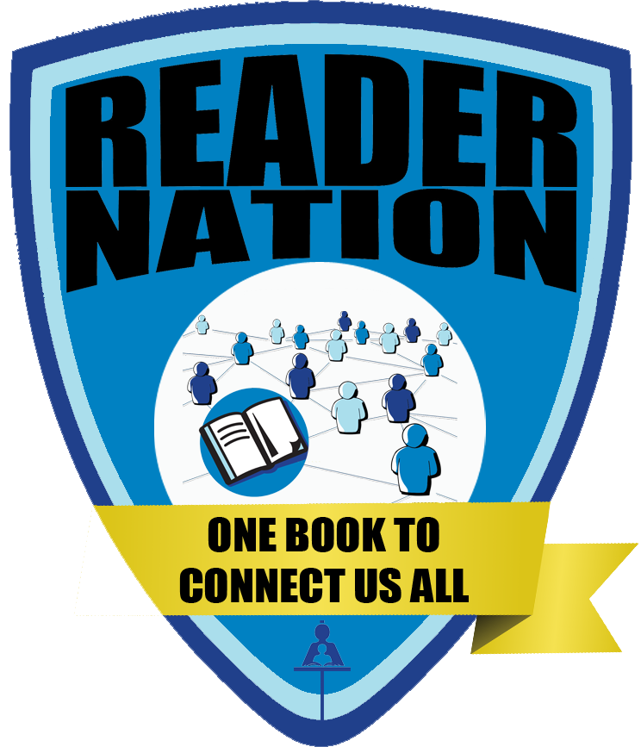
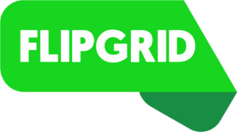
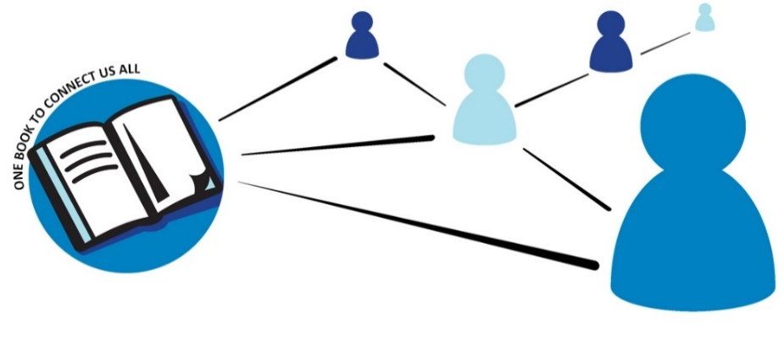

- Open Flipgrid
- Use the code readernation
- Enter the student ID or scan the QR Code


- Select your grade level and language
- Click to add your video

- Click to record your video. Wait for the countdown.

- Click to pause/resume your recording
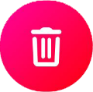
- Click to review your response
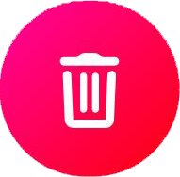
- Can you hear yourself clearly? If not, click to re-record
- You can click to trim your video from the beginning or the end

- Click if you are satisfied with your recording
- Click to snap your selfie
- Click to proceed
- 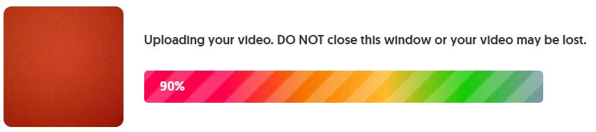Wait for your video to be uploaded
- 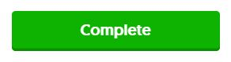 means your video is uploaded
- Click

Once your teacher librarian has viewed your video, it will appear on the #ReaderNation grid for others to view!

